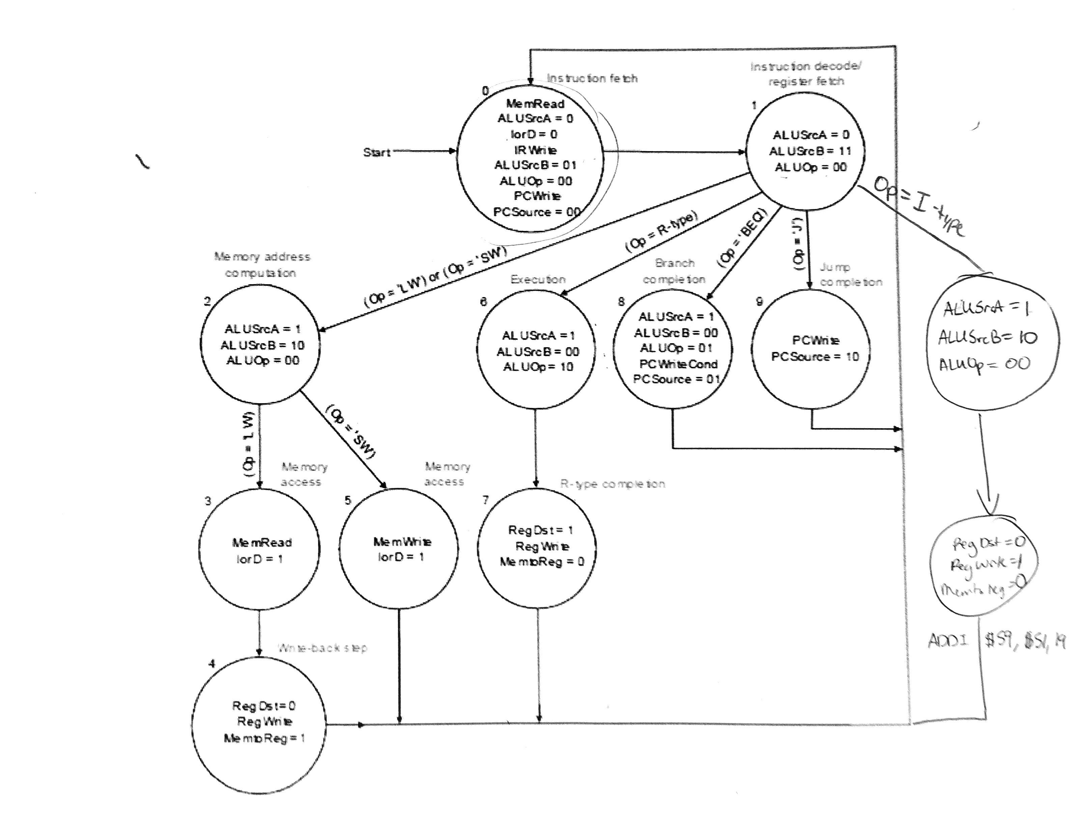

We have 3 main types of instructions. R-type, I-type, and J-type instructions. These use the hardware a bit differently to get the result we want. We are using two different memory modules. One is to store our instructions and then the other is to store the values of our instructions for later use, that way we don’t have to worry about memory management and stack control.

R-type instructions == [31:26] Opcode | [25:21] R1 | [20:16] R2 | [15:11] R3

I-type instructions == [31:26] Opcode | [25:21] R1 | [20:16] R2 | [15:0] Immediate

J-type instructions == [31:26] Opcode | [25:0] jump address

